
BROKEN OBJECT LEVEL AUTHORIZATION (BOLA) REPORT
DEMILADE ADEISRAEL

Summary
According to OWASP, Broken Object Level Authoristation (BOLA) is a security flaw that occurs when an API (Application Programming Interface) does not properly enforce authorisation checks for each object accessed by a client. Attackers can manipulate Resource ID, tokens, etc to access resources that they’re not authorised for example PII (Personally Identifiable Information).

Objective
The objective of this assessment was to determine whether an authenticated user could access API resources belonging to another user by manipulating object-level identifiers. The assessment specifically focused on verifying whether the API enforced authorisation checks on individual resources after authentication.

Test Summary
The BOLA vulnerability exploited on crAPI was done by gaining unauthorised access to other Users’ Mechanic Reports. These reports contained significant records of PII like phone numbers, emails, and VIN (Vehicle Identification Number). The API endpoint handles access control poorly by determining which mechanic report to display based solely on a sequential ID parameter passed in the URL path, failing to verify whether the authenticated user owns that specific resource.

Tools Used

Tool | Purpose
Burp Suite | Intercepting, modifying and replaying HTTP requests
Postman | Sending and validating API requests
crAPI | Intentionally vulnerable API security lab

Severity
Risk Rating | CVSS v3.1 Score | Vulnerability Type | Target Endpoint
HIGH | 8.5 | CWE-639: IDOR / BOLA | GET /workshop/api/merchant/contact_mechanic/{{id}}

Impact

HIGH (Severe Data Exposure)

Confidentiality: Bypassing this authorisation barrier results in a total loss of confidentiality for the affected resources. An attacker gains access to restricted Personally Identifiable Information (PII), asset identifiers, and private records.

Integrity & Availability: While this specific read-only endpoint does not allow an attacker to modify and read data directly, the scope of information gathered can easily be weaponised for secondary social engineering or targeted phishing attacks.

Findings & Analysis
This section would contain the step by step process to which this BOLA vulnerability was exploited on crAPI. It would also contain screenshots from the lab to provide better understanding of the processes executed. These steps were carried out after creation of user “alice123@email.com” on crAPI.

STEP 1 - Login & acquire valid Session Token to capture requests
After creating a user and logging in to acquire a valid session token (Figure 1), it was possible to initiate and capture requests from crAPI to Postman (Figure 2) by intercepting traffic while using the website as intended. Doing this would make it possible to discover endpoints that would be susceptible to a possible BOLA attack.

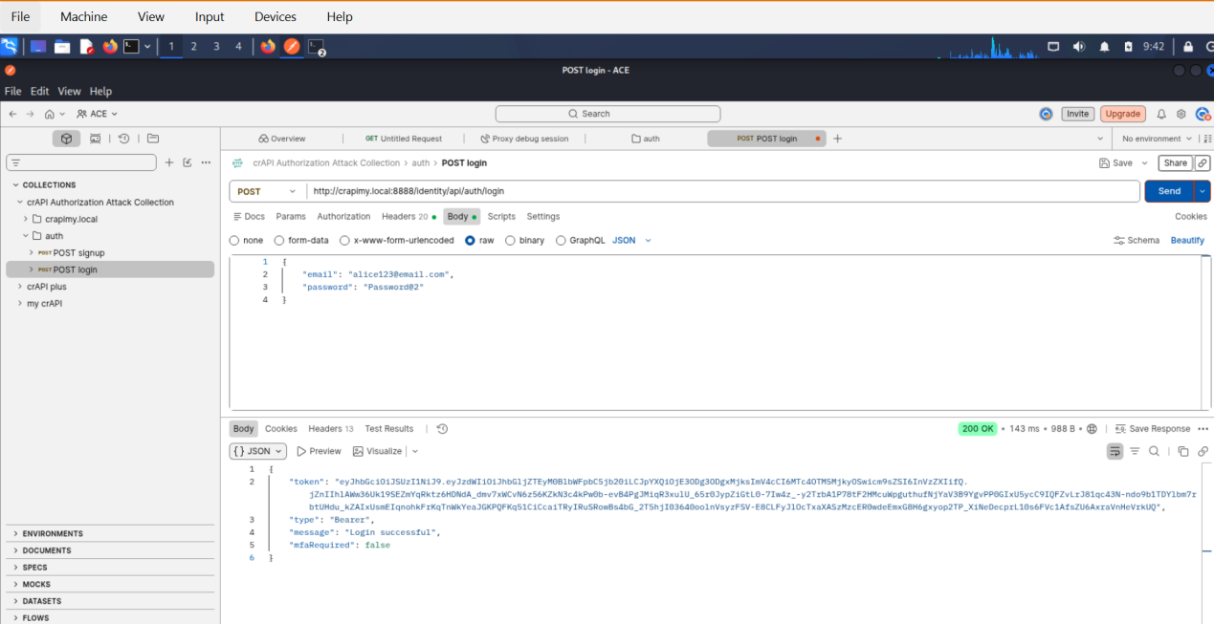
Figure 1
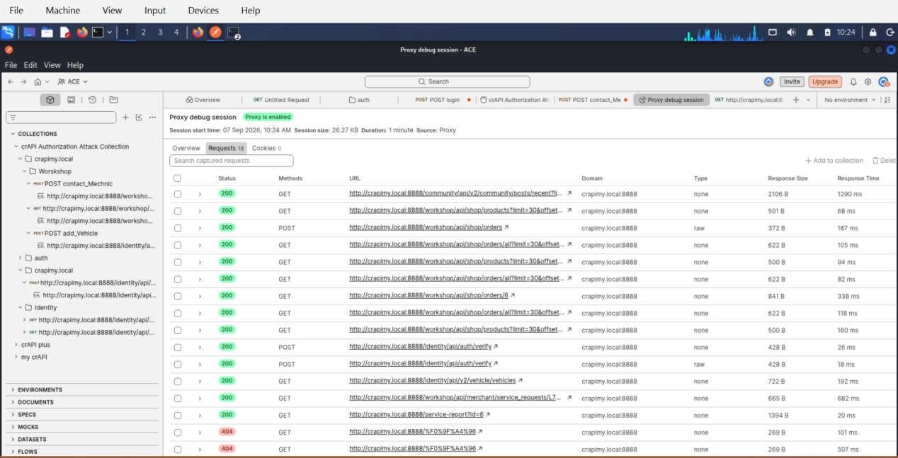
Figure 2

STEP 2 - Identify & Modifying the Request
The intercepted request was sent to Burp Repeater (Figure 3) and a 200 response was received with a report link. This URL link was then used to replace the initial POST request and construct a GET request (Figure 4). This request delivered a valid response with the user’s mechanic report details. Having seen this, The sequential integer identifier at the end of the URL string is manually changed from 11 to 1 to attempt access to an unauthorized object resource.

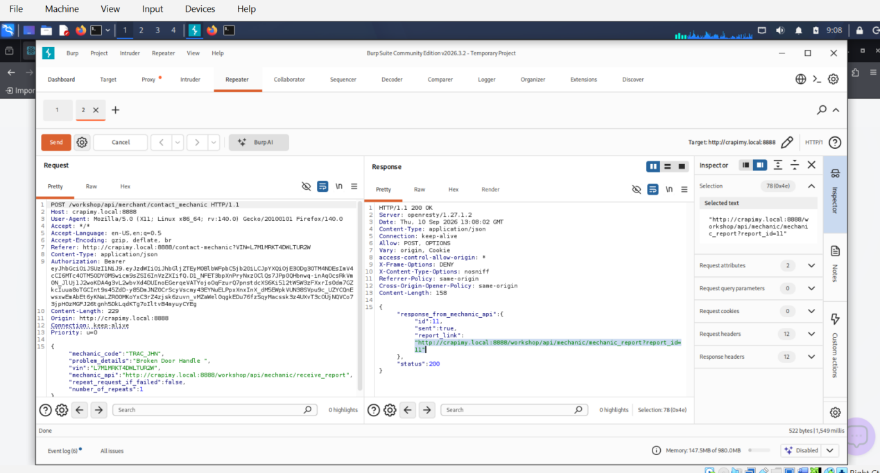
Figure 3

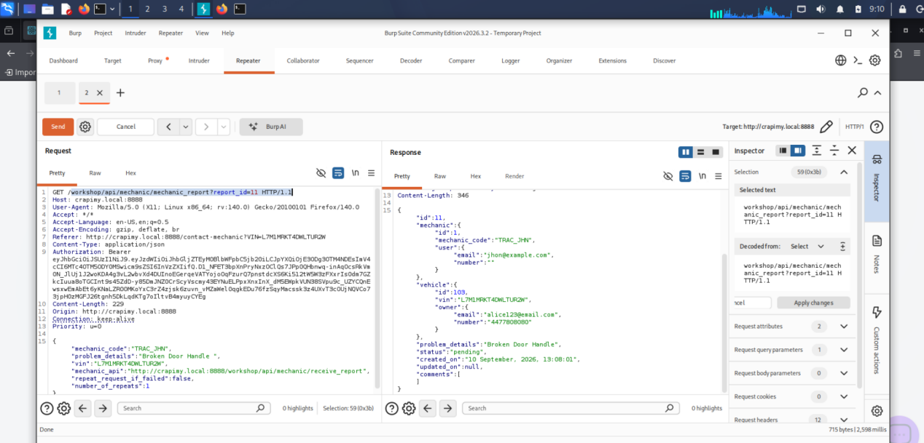
Figure 4

STEP 3 - Unauthorised Data Leakage
The server responds with an HTTP 200 OK status code, completely bypassing authorisation controls and leaking the vehicle data of an external user (Figure 5). This was also tested by changing the “report_id” from 1 to 3 (Figure 6), thereby leaking more JSON metadata about another user.

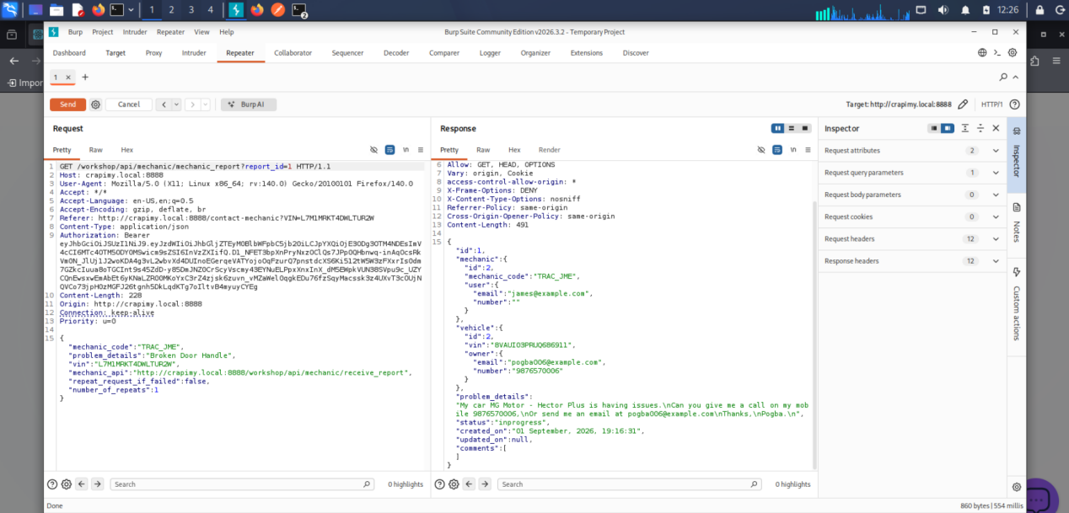
Figure 5

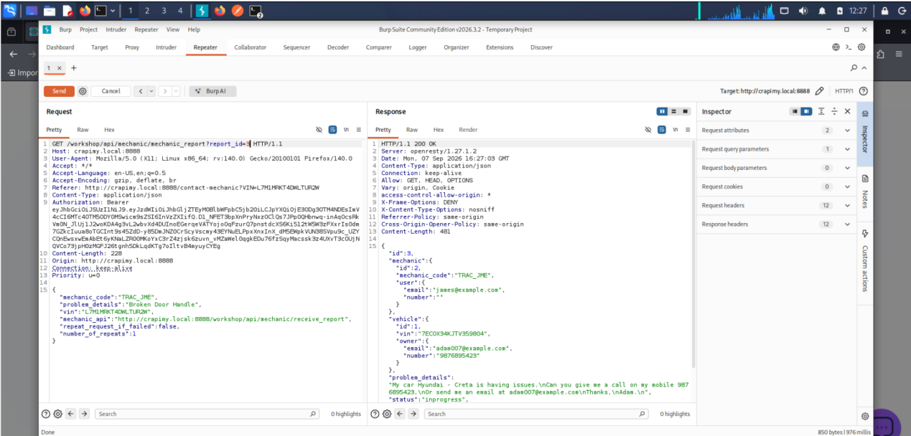
Figure 6

Remediation
According to OWASP Website Security Testing Guide API Testing, here are ways that BOLA can be remediated:
- Object Ownership Checks: Ensure that object-level authorization checks are performed for every API request. Always verify that the user making the request is authorized to access the requested object.
- Role-Based Access Control (RBAC): Implement RBAC policies that define which roles can access or modify specific objects.
- Least Privilege Principle: Apply the principle of least privilege to ensure that users can only access the minimum set of objects they need for their role.
- Use UUIDs (Universally Unique Identifier) or Non-Sequential IDs: Prefer non-predictable, non-sequential object identifiers (e.g., UUIDs instead of simple integers) to make enumeration and brute-force attacks harder.

Methodology

Risk Matrics Description
Factor Breakdowns
- Likelihood: HIGH (Certain / Trivial)

Attack Complexity (AC: L): Low. Exploiting this vulnerability does not require specialized conditions, precise timing, or advanced technical evasion techniques. It relies on standard browser proxy manipulation tools (Postman/Burp Suite).

Privileges Required (PR: L): Low. Any standard, self-registered user on the platform possesses the necessary access level to initiate the attack vector.

User Interaction (UI: N): None. The exploit executes completely silently on the backend API without requiring the victim to click a link, open an attachment, or take any action.

2. Risk Matrix Calculation
By mapping a High Likelihood of exploitability against a High Business Impact regarding data confidentiality, the vulnerability automatically escalates into a High Risk tier.

3. CVSS v3.1 Vector Breakdown
The assigned vector string CVSS:3.1/AV:N/AC:L/PR:L/UI:N/S:C/C:H/I:N/A:N formally indicates:

Attack Vector: Network (AV:N) — Exploit is launched remotely over the internet.

Scope: Changed (S:C) — Bypassing the authentication mechanism on this endpoint allows an attacker to directly access data managed under a completely different user scope.

References
OWASP
Hackerone
CVSS

